**IELTS Writing Task**

**Task 1**

***1, How to wrtie an introduction paragraph?***

**1.1, Bar Charts**

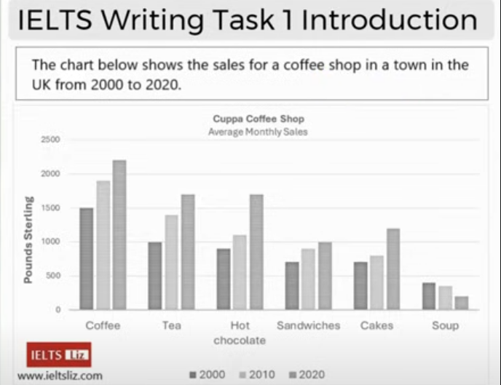

***A wrong example***

The diagram below give the information for the sales of, for example tea, coffee, hot chocolate, food in a café, which locates in an English village, from 2000 to 2020. Units measure in Pounds Sterling.

***Analyses:***

There are 15 mistakes in total.

1, It is not a diagram but a bar chart.

2, “below” : The bar chart is neither below nor above.

3, “the information”: The definite article “the” should not be used here because “infromation” is mentioned for the first time.

4, “the sales” : It only gives an overall/general idea. Use “typcally monthly sale”

5, “for example”: We are going to report the factual information in Task 1 not give examples.

**“tea, coffee, hot chocolate, food…”**

6, These categories are in wrong order.

7, The last three categories should not be summarised because the three drinks have been listed one by one. If there were only a few categories in a bar chart, it would be no problem to list them all. But if there were many ones, they should be summarised. In the following bar chart(Figure 1.1), we should write that “nine ages groups” instead of listing them all because there are many groups.

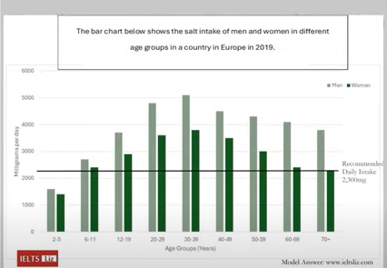 Figure 1.1

8, There should be an “and” before the last category.

9, “cafe”: This word could not used to paraphrase “coffee shop” because it has a different meaning.

**“which locates in an English village”:**

10, “locates” : is located (passive voice)

11, “in English” : In the description it is “UK” which means the whole Britain while “English” just means “of England”. It is a big mistake here.

12, “village”: It is a town not a village. “cities > towns > villages > hamlets”

13, “from…to…”: They are in the description we should easily paraphrase it by “between…and…”. Don’t ignore it and everyone of all levels of English should use different words from the decription if possible.

**“Units measure in Pound Sterling”**

14, “measure”: are measured (It should be a passive voice.)

15, “Pound Sterling”: Initial capital words are usually used in titles and bar charts like this one but when you use them in sentences they should be grammatically correct, namely they can’t be capitialised.

***After corrected***

The bar chart gives information for the typical monthly sales of coffee, tea, hot chocolate, sandwiches, cakes and soup for Cuppa Coffee Shop, which is located in a British town, between 2000 and 2020. Units are measured in pounds sterling.

***Improved with more formal and academic words. It gets band 8 or higher.***

**Example 1**

The bar chart illutrates the amount of money made from the sales of coffee, tea, hot cholocate, sandwiches, cakes and soup in a typical month in Cuppa Coffee Shop, (which is) located in a British town, in 2000, 2010 and 2020. Units are measured in pounds sterling.

1. illutrate: This is an academica word which helps you achieve a high score.
2. in a typical month: Paraphrase with different structure of sentences.
3. in 2000, 2010 and 2020: It is more accurate than giving only two years in “between 2000 and 2020”.

**1.2 A table and a pie chart**

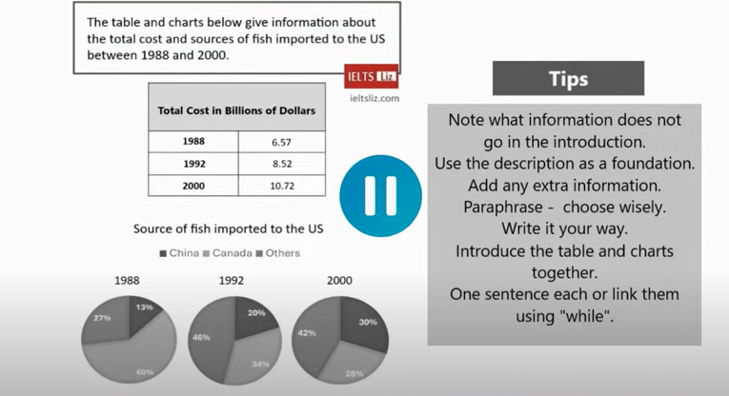

***(1) My introduction:***

The table illutrates (information of) overall expenditure on fish in the America in 1988, 1992, and 2000; units are measured in billions of dollars. The pie charts demonstrates from which countries it was imported and the percentage of each place.

***Mistakes:***

1. illutrates overall expenditure:

It is not a proper collation since expenditure can not be “illutrated”.

The correct statement is “illutrates information of overall expenditure”. Don not add the difinite article “the” before “information” because it is the first time that it appears.

1. on fish: I did not stated clearly where the fish come from. Fish might be from domestic markets or international markets. Whereas, it was imported fish that the introduction said.
2. Where was the fish imported?

I did not write from which countries the fish was imported from. Since there are only three countries, I should have listed them all.

1. The data of pie charts was coordinately in the same year of the table. Whereas, I did not show information about how many the pie charts are and their relation with the table.

***Improved***

The table illutrates information of overall expenditure on imported fish in the America in 1988, 1992 and 2000; units are measured in billions of dollars. The three pie charts demonstrates the proportion of the fish purchased in China, Canada and other countries in the same three years.

***(2) Other examples***

The table shows how much the US spent in total on imported fish in 1988, 1992 and 2000, while the pie charts illutrate the proportion of fish brought in from China, Canada and other countries. Units are measured in billions of dollars in the table ~~and percentage in the pie charts.~~

***Mistakes***

1. There are too many words in this introduction paragraph, while the total number of words in Task 1 in IELTS is between 150 and 180 words. “proportioin…” and “percentage” are duplicated; thus one of them should be eliminated.
2. Subsequently, it is not coherent after deleting “percentage” since it illurates the table first; then the pie charts; then the table. It is not logical.
3. This example did not state that the pie charts were in the same three years of the table.

***Improved***

The table shows how much the US spent, in billions of dollars, on imported fish in 1988, 1992 and 2000, while the pie charts illutrate the proportion of the fish brought in from China, Canada and other countries in the same three years.

**An alternative of this example**

The table show the total expenditure of the US, in billions of dollars, on imported fish in 1988, 1992 and 2000, while the three pie charts the proportion of fish that was sourced from China, Canada and other countries in the same three years.

**N.B.** “source” is a noun in the introduction of the question, while it is a verb in this paragraph. Using multiple parts of speech in a word is encouraged and can be considered a form of paraphrase to some extent.

**1.3 Diagram**

***Example 1***

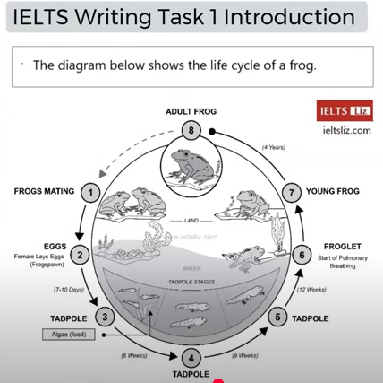

*Analyses:*

Apparently, there is no need to paraphrase the word “diagram”; a diagram is a diagram. Neither is “frog”. What needs to be paraphased is “shows the life cycle”.

*My introduction*

The diagram illustrates stages of the life of a frog.

*Improved*

1. The diagram illustrates the statges in the life of a frog
2. The diagram illustrates the phases (that) a frog passes through during its life.
3. The diagram illustrates the stages of development that a frog passes through during its lifetime.

The third sentence is the best. It is not about the length of sentences, but how a precise and specific introduction it is. Obviously, the last one is an introduction which offers more detailed information and perhaps is given a higher band score.

***Example 2***

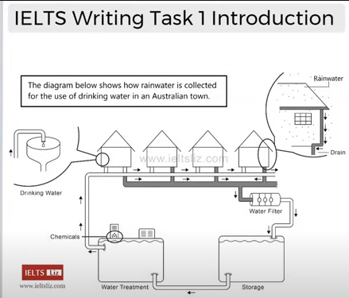

***My introduction***

The diagram demonstrates the process of rain being converted to clean water to drink in a town of Australia.

***Improved***:

The diagram demonstrates the process of rainwater being purified into clean drinking water in a town in Australia.

Note: there is no need to paraphrase “rainwater”.

***Examples***

(The following introduction paragraphs is in the range between band score 5 to 6.):

1. The diagram illutrates the way (that) rainwater is collected for use as drinking water in a town in Australia.
2. The diagram illutrates the process of collecting rainwater in order to use it for drinking water in a town in Australia.
3. The diagram illutrates the collection of rainwater and how it is processed to be used for drinking water in a town in Australia.
4. The diagram illutrates the way (that) a town in Australia collects and processes rainwater to be used for drinking water.

N.B. In this example “a town…” is subject and verbs are active.

*These examples below are more precise and specific and thus causes higher band scores; that proves the writer is an independent user.*

1. The diagram illutrates a town in Australia recycles rainwater to make it safe for drinking.
2. The diagram illutrates a town in Australia harvests and recycles rainwater so that it can be safely consumed.

“harvest” and “consume” are formal words.

**2. Exercises**

**I, Pie Charts**

**1.1 A Demo**

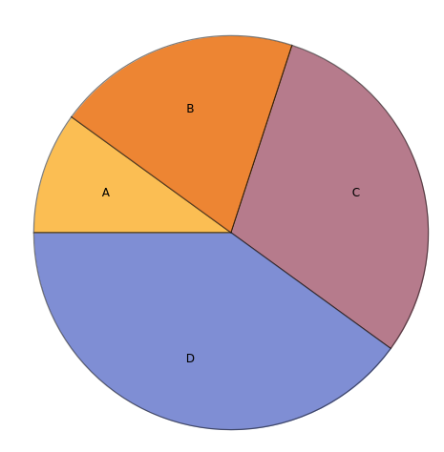

It is evident that A is the smallest segment, accouting for around 10%. On the contrary, D is the largest part, and approximately 40% is representd by D. While a total of 50% is made by B and C, but B is slightly larger than C.

***A Model Answer***

The pie chart illustrates the distribution of four categories: A, B, C, and D. It is clear that Category A is the smallest segment, accounting for just over 10% of the total. In contrast, Category D is the largest, representing approximately 40% of the pie chart. Categories B and C are similar in size, each making up roughly a quarter of the total. While Category B is slightly larger than Category C, the difference is not significant. In conclusion, the pie chart shows a clear disparity between the smallest and largest categories, with Category D being nearly four times the size of Category A. The remaining categories, B and C, together account for half of the total.

**II. Bar Charts**

**1)** [**Expenditure on consumer goods**](https://ieltsliz.com/ielts-sample-chart-for-writing-task-1/)**(IELTS Liz)**

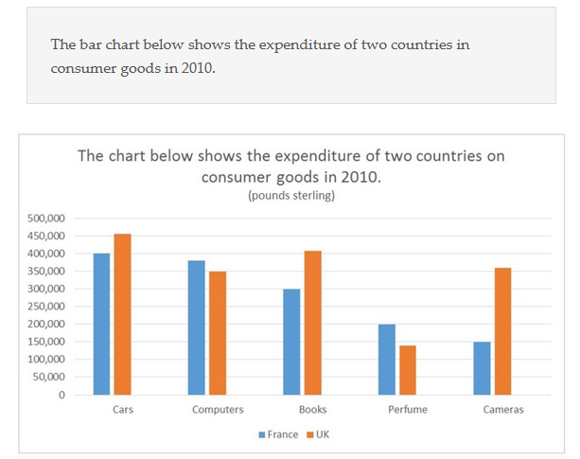

***My Report 1***

The bar chart illustrates how much money consumers spend on five categories which are cars, computers, books, perfume and cameras in France and UK in 2010 and the currency unit is pound sterling.

Consumption of cars, and books in UK are relatively higher than them in France. Moreover, the sales of cameras in the former country are significant and more than two times as in the latter. Whereas, French buy more computers and perfume than British.

On ther other hand, in Britain, the numbers of buyers in these goods are not remarkably distinct while in France purchasers tend to spend much more on the first three than the rest two. Cars are the largest amount of money spent in both countries.

In general, people in UK consume more these products than in France, especially in books and cameras, either of which cost more than forty thousand pounds. But French buy more computers and perfume.

***Analyses (plural)***

1, The report doesn’t incorporate statistics/data(numbers or dates if possible) in body paragraphs to support the theses or statement.

2, Some verbs should be past tense, as highlighted in yellow background.

3, The third paragraph is not understandable since it is not so logical that it is difficult for readers to find out which is “the former” or which is “the rest”.

3, The overview paragraph is not quite clear. It is better to summarise in three aspects which are British consuming more goods than French in total, both countries spent the most money on cars and that France spent the least on camera and UK on perfume.

4, For body paragraphs, there are two altenatives to organise them logically.   
The first one is, as in the order of the overview paragraph, that cars, perfume and cameras are in a body paragraph and computer and books are in the other. Because the expenditure of cars are the highest in the two countries while perfume and cameras are the least in UK and France, respectively. Then the rest two categories are in the other body paragraph.   
The second is that cars, books and cameras are in one body paragraph; British spent more money than French. Computers and perfume are in the other; French consumed more of them than British.

I prefer to choose the second way.

***(My report is revised as follows.)***

The bar chart illutrates the amount of money spent on five categories of consumer goods, which are cars, computers, books, perfume and cameras, in UK and France in 2010. Currency unit is pounds sterling.

Overall, the total expenditure in Britain was higher than that in France. Customers from both countries spent their most money on cars. On the other hand, British bought the least perfume while French purchased the least cameras.

Specifically, British spent about £450,000 on cars comparing with French at exact £400,000. Similiarly, the expenditure of books in UK was ~~much~~(quite) higher than that in France, which were slightly over £400,000 and nearly £300,000, respectively. Whereas, the expenditure of cameras in Britain(over £350,000) were more than two times of in France, which was only £150,000.

On the contrary, people in France paid more on the rest goods than in UK. The amount of money French spent on computers was £350,000, which was more than that (£300,000) spent by British. Both countries spent a little money on perfume, purchasers in France paid £200,000 and those in British paid less than £150,000.

[***A model answer***](https://ieltsliz.com/ielts-model-bar-chart-band-score-9/)

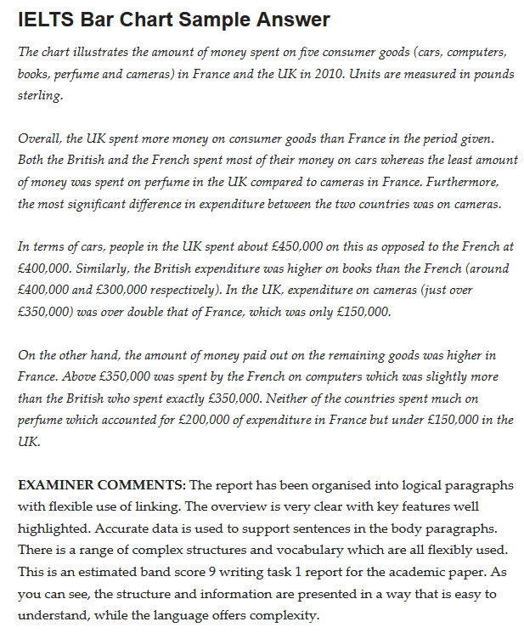

***My Report 2 (adopting the first way mentioned in the 4th note above.)***

The bar chart illustrates the money that British and French spent on cars, computers, books, perfume and cameras in 2010. Units are measured in pound sterling.

Generaly[Generally], Britain consumed more than France in total. Both countries spent the most money on cars. Whereas, the least amout[amount] of money was spent on perfume in UK while on camera in France. In addition, the most significant difference between two countries was in the consumption of cameras.

In terms of cars, the amount of money spent by British was just over £450,000 and that of French was exactly £400,000. Britain spent less than £150,000 on perfume compared £200,000 in France. Whereas, there was a sharp contrast in the expenditure of cameras; consumers in UK spent ~~a little bit~~[just] more than £350,000 which was as more than two times as the amount (£150,000) in France.

For computers, it cost(s) British cosumers[consumers] about £375,000 and French £300,000. People in [the]UK spent around £400,000 on books while those in France spent £300,000.

***Errors and mistakes in my report 2***

1. “that British and French...” -> that the British...
2. pounds sterling: “pounds” is plural.
3. “perfume in UK”: perfume in the UK
4. “between two countries”: between the two countries...
5. on the consumption
6. compared to...
7. “a little bit more thatn...” is colloquial, we should use “just” instead.  
   **just**: by a small amount.
8. “People in UK spent around £400,000 on books while those in France spent £300,000.”.  
   There are two “spent”s in this sentence, which is not encouraged in IELTS and leads to a lower band score.
9. The second body paragraph is too short. In oder to make it lenghier, a thesis should be added at the beginning of the second body paragraph; it is that “On the other hand, French consumed more on remaining goods than British.” Then the point should be supported by detailed data.

***My report 3 after being improved.***

The bar chart illustrates the information of the amount of money spent on cunsumer goods, which are cars, computers, books, perfume and cameras, in the UK and France in 2010. Units are measured in pounds sterling.

Overall, Britain spent more than France did and the most money for the both countries was used on cars. Whereas, the least money spent on perfume in the UK compared to cameras in France. In addition, the most significant difference of expenditure between two countries was on cameras.

In terms of cars, consumers in the UK spent more than those in France, the expenditure of two countries were £450,000 and £400,000, respectively. Similarly, British spent approximately £400,000 on books which was rather higher than £300,000 paid out by Franch. Furthermore, the expenditure of cameras in the UK(above £350,000) was over double that of France(£150,000).

On the other hand, French spent more on the remaining two good than British. The amount of money that buyers in France spent on computers was around £375,000 as opposed to the exact £350,000 in the UK. The expenditure of perfume was £200,000 in France and less than £150,000 in Britain.

**2) Eating Fruit and Vegetables**

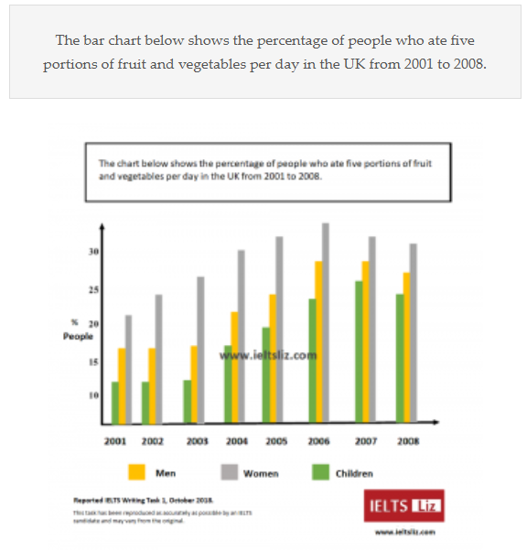

The bar charts(1) illustrates the percentage of men, women and children who have (had) five portions of fruit and vegetables each day in the UK from 2001 to 2008.

Overall, the largest percentage of people who consumed green food is(2) women compared to men and children. The percentage of women increased steadily from 2001 to 2006 and then fell gradually to the year of 2008, while that of men and children reached their highest point in 2007 and slightly dropped in 2008. In addition, the gap(3) between three(4) categories were shrinking dramatically during this period.

The percentage of women who had fruit and vegetables was always higher than 20%. It had been kept above 30% since 2004 and had never fallen until 2008. This group of women accounted for just over 20% in 2001 and continued to raise its peak, nearly 40% in 2006, before it began to fell(5) steadily to around 30% in 2008.

On the other hand, the percentage of men and children kept steady in the first three years with over 15% and about 12%, respectively. In the year of(6) 2004, the percentage of men increased over 20%,(7) while the data of(8) chilren(9) was merely 20% in the next year. The people who ate greens had never been overcome 30% in the given time.

***Analyses***

What are five portions of fruit and vegetables?

They are five different kind of fruit and vegetables a person eats everyday to keep healthy.

***Errors in my report***

1. “chart” is singular. There is only one bar chart.
2. “is”: was
3. gap: gaps
4. three: the three
5. fell: began to fall. (“to” is an infinitive marker, not a preposition)
6. in the year ~~of~~ 2004
7. increased by over 20%
8. of: for
9. children. (spelling error)

***Other errors***

1. “greens” can NOT represent fruit and vegetables as I thought before; it only represents green vegetables in British English. If you want to refer to them with a word, you can say “produce” or “plant-basted food”. For instance, we can say, “I want to eat fresh produce.”
2. On ther other hand, there are over 200 words in my report, which is not allowed in IELTS writing task 1. Usually, the number of words is between 150 and 190.

***Summary and How to write***

*Overview Paragraph*

1. The proportion of women was the highest.
2. That of chidren was the lowest
3. The percentage increased steadily during most of the given period.
4. The gaps or differences of percentage between the three groups were becoming smaller.

*Body Paragraph 1*

Women

1. Describe when the percentage reached its peak.
2. Use data to support your thesis.

*Body Paragraph 2*

Men and Children.

1. The steady in the first three years of the data of these two groups.
2. When they reached their peaks.
3. Don’t forget data.

***Revised Edition***

The bar chart illustrates the proportion of women, men and children who consumed five kind of fruit and vegetables each day between 2001 and 2008.

Overall, the largest percentage of people eating fresh produce was women while the smallest proportion was children consistantly. The gaps between the three groups of people were shrinking as the data steadily increased.

The percentage of women eating fruit and vegetables was 20% In 2001 it increased gradually to its peak at 35% in 2006. After that, it began to fell steadily to about 32% in the final year 2008.

When it comes to men and children, the proportion of them kept stable in the first three years at 17% and 12%, respectively. Then the data of men steadily rose to 27% in 2006(1) and fell slightly to 25% in 2008. Whereas, the percentage of children increased to its highest point, which was 25% in 2007, and dropped to around 23% in the next year.

***Errors and imporment of my revised edition.***

1. It is better to add that the figure was at a peak in 2006.  
   “...rose to a peak at 27% in 2006...”

[*A Model Answer from IELTS Liz*](https://ieltsliz.com/ielts-model-answer-bar-chart-october-2018/)

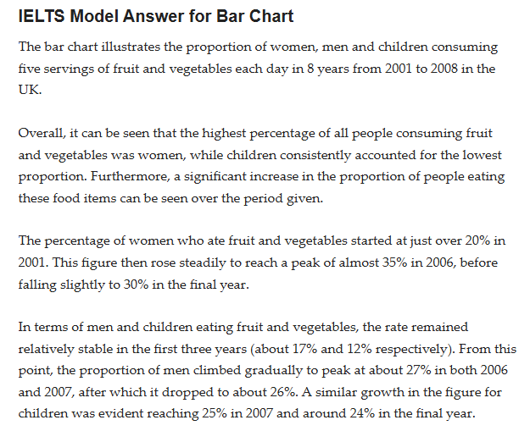

**3) Teenager’s activities**

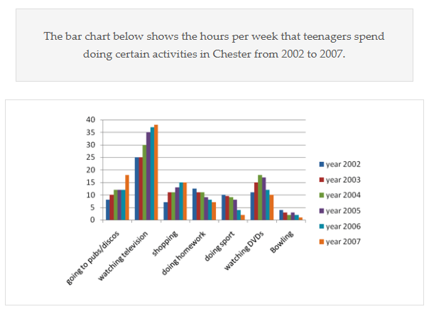

***My Report***

The bar chart illustrates the time each week teenagers spent doing seven kinds of activities in Chester in the years between 2002 and 2007. Units are measured in hours.

Overall, during the given period, watching televison(1) was the largest amount of time, while bowling consistently was the smallest. The amount of time spent on going pubs(2) or discos, watching TV and shopping were(3) increasing. Whereas, hours consumed on doing homework, doing sport and bowling gradually decreased.

In terms of watching television, it took exactly 25 hours in the first two years and then the amount rised(4) drastically in 2004 and 2005 by 5 hours a year; the figure reached ~~to~~(5) approximately 37 hours in the final year. To be contrast, they spent less than 5 hours on bowling in 2002 and the number dropped to only an hour in 2007.

Whereas, the hours spent on going to pubs or discos grew steadily from 2002 to 2004 and kept steady before it increased steeply to about 17.5 hours in 2007. Time cost on shopping was over 5 hours in 2002 and increased to 15 hours in the final year. On the contrary, the amount of time spent on doing homework head downwards from 12 hours in 2002 to about 7 hours in 2007. It was the same with doing sport on which the time dropped from 10 hours in the first year to 2 hours in 2007.

* Too many words.

***Errors***

1. spelling error. television
2. going to pubs
3. was
4. rose
5. reach ~~to~~

***Improved***

***Paragraph 2***

1. watching television occupied the largest amount of time, while bowling took the least.
2. “The amount of time spent on going pubs or discos, watching TV and shopping were increasing. Whereas, hours consumed on doing homework, doing sport and bowling gradually decreased”

The tense of these two sentences are inconsistent. The first one is past continuous and the second one is past simple. It is not coherent to write so. Either of the two tense is appropriate.

1. There are repeated words in this paragraph; “the amount of time” appeared two times. It is easy to use “hours” instead.

For instance, the hours spent on going to pubs…

[A Model Answer From Liz](https://ieltsliz.com/full-model-answer-to-bar-chart-lesson/) . [Local](images/Teenager%20Activities.png)

***Rewritten By Me***

*(N.B. there are too many words in my first edition so I have to revise every paragraphs to eliminate cluttered words. Therefore, my report will become much more concise and coherent.)*

The bar chart illustrates how many hours that adolescents in Chester spent on seven activities each week between 2002 and 2007.

Overall, watching television consistantly occupied the most hours while bowling took the least during the given period. Hours spent on going to pubs or discos, watching television and shopping increased. On the contrast, time consumed on the rest decreased except for the fluctuation of watching DVDs.

Teenagers spent approximately 7 hours on going to pubs or discos, this figure was over doubled in the final year. 25 hours were spent on watching TV in 2002 and it increased to about 40 hours in 2007. The hours spent on shopping was 7 and rose to 15 in the last year.

On the contrary, the time that they spent on doing homework gradually dropped from 12 hours to about 7 hours per week. There was also a slide in the time for doing sport, which was 10 hours in 2002 and fell sharply to 2 hours in the final year. Whereas, the time dedicated to watching DVDs was fluctuated, which reached its peak in 2004 and then dropped.